基隆市南榮國中攜手計畫課業輔導學習單-1
科目：英語 學習內容：8下 Unit 1-1 班級：_______ 學生姓名：_______________
一、文意字彙（每題5分，共60%）
1. large This car is too small. We need a l e one.
2. heavy Tina is in bed with a h y cold. She can’t go to school.
3. neighbor Mr. Smith is our n r. He lives in the house next to us.
4 move Mr. and Mrs. Chen plan to m e into their new house next week.
5. knife I always use a k e and fork for my meals.
6. toys Time for bed, Amy. Put your t ys away in the box.
7. camera I took pictures of the koalas with my new c a.
8. machine She put her dirty clothes in the washing m e and washed them.
9. comfortable I wear these shoes to school every day because they are very c e.
10. cash She brought a lot of money with her, so she could pay in c h for
her new bag.
11. price A: What is the p e of this book? B: NT$620.
12. total There are 43 students in our class in t l.

二、請依照圖，填入正確的字（每題5分，共20%）

1.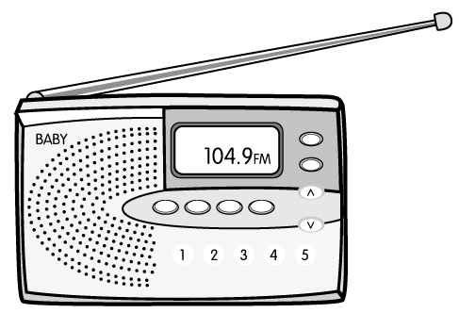 | 2.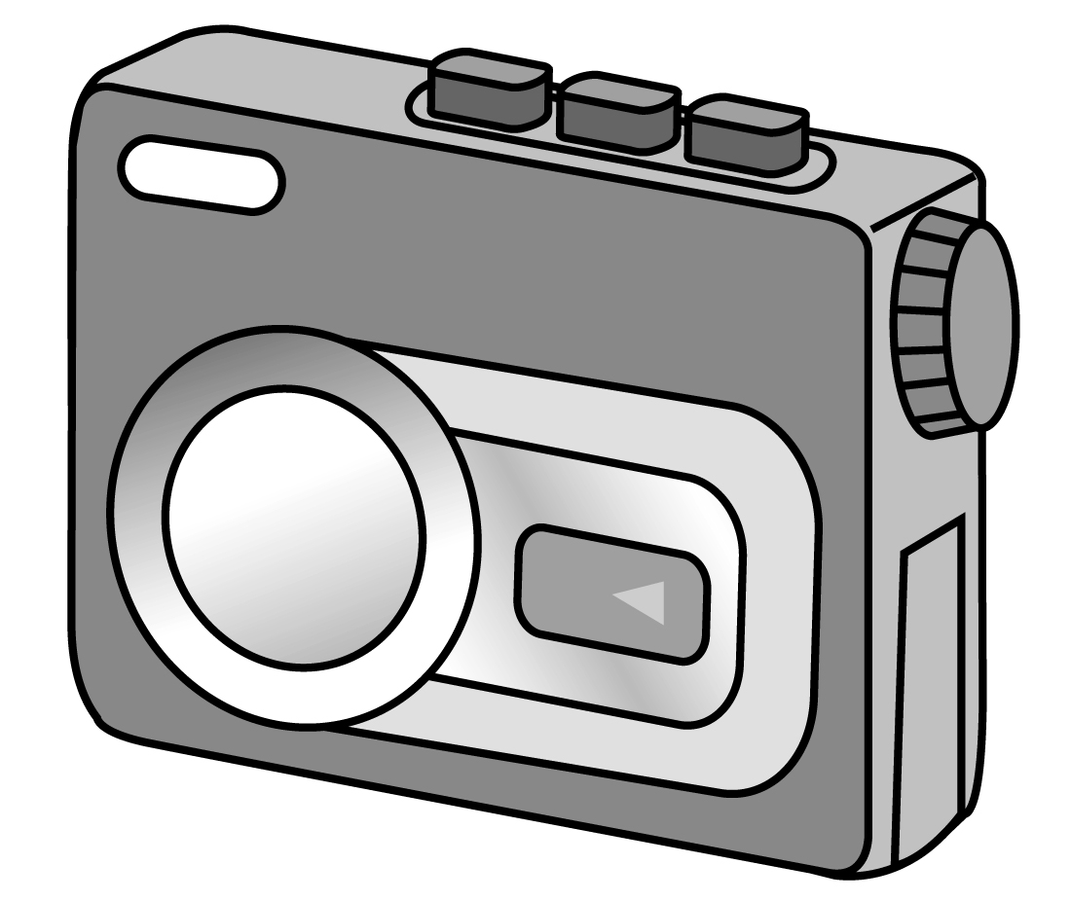 | 3.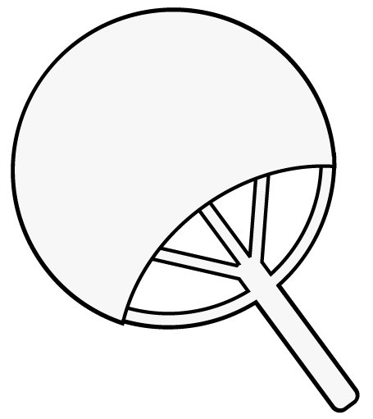 | 4.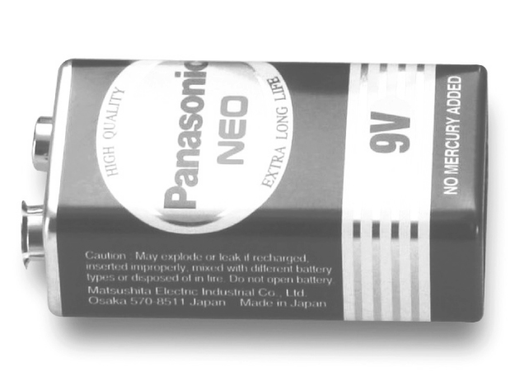
radio | tape recorder | fan | battery

三、選擇（每題4分，共20%）
1.（ D ） Mary is than Sara.
(A) very nice (B) much interesting (C) so happy (D) more careful
2.（ D ） Jessie is of the two.
(A) the busy (B) taller (C) much nicer (D) the heavier
3.（ C ） I need a computer! I’m going to buy tomorrow.
(A) another (B) some (C) one (D) others
4.（ A ） This piano is more than that.
(A) expensive (B) light (C) cheap (D) larger
5.（ B ） Mrs. Chan is younger than her husband.
(A) more (B) much (C) most (D) very

基隆市98學年度第2學期南榮國中攜手計畫課業輔導學習單-2
科目：英語 學習內容：8下 Unit 1-2 班級：_______ 學生姓名：_______________
一、翻譯（每題14分，共70%）
1. A：你要如何付錢呢？ B：用現金。
A: How would you like to pay? B: In cash.
2. 我想要那些紅色的，但它們貴的多了。
I’d like the red ones, but they are much more expensive.
3. 較小的那一個比較大的那一個差。
The smaller one is worse than the bigger one.
4. 你可以使用這個CD播放機聽收音機。
You can listen to the radio with the CD player.
5. 貝克一家計畫四月份搬至較寬大且較舒適的房子。
The Becks plan(ned) to move to a larger and more comfortable house in April.
二、閱讀測驗（每題10分，共30%）
Early this morning, a young man robbed a bank, and a policeman is now asking a bank clerk about the robber.
Policeman : Look at this picture. Is that the man?
Mr. Lin : No, that isn’t the man. He had longer and straighter hair than that.
Policeman : Did you see his face?
Mr. Lin : Yes. It was thinner than that.
Policeman : Anything else?
Mr. Lin : Yes. The man had a longer nose than that, too.
Policeman : Good. What else did you see?
Mr. Lin : Oh, I remember. The man had large ears, and his mouth was big, too, but he had very small eyes.
rob搶劫 robber搶劫者 curly捲的

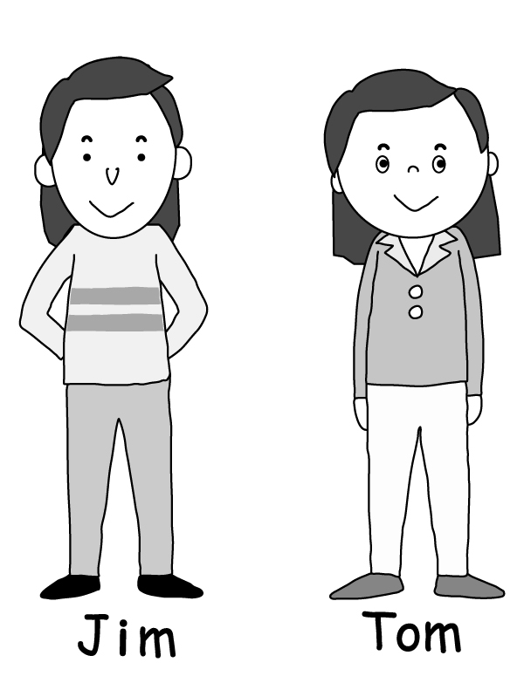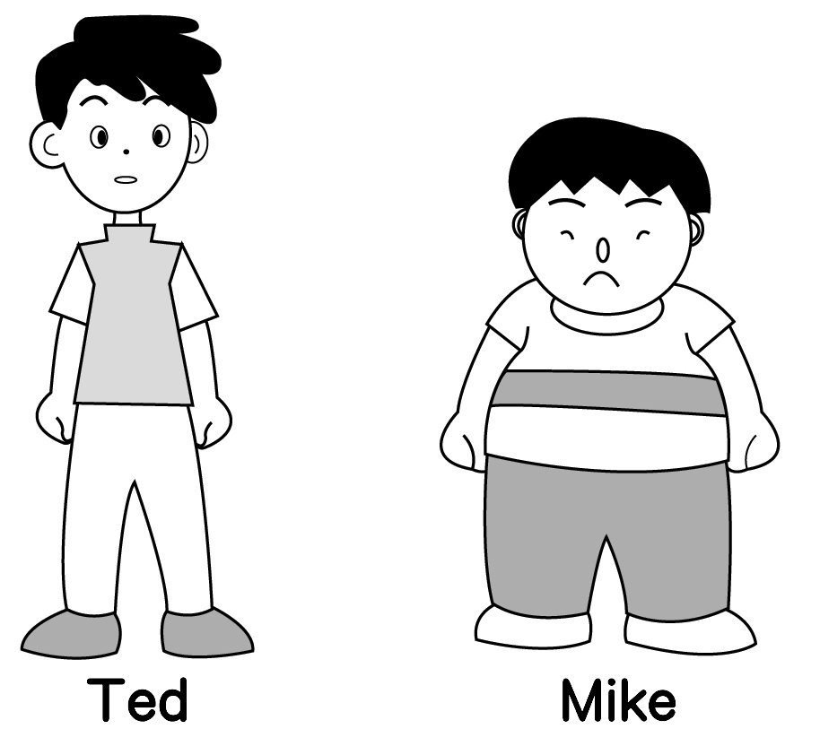
1.（ C ） Who was the robber?
(A) Ted. (B) Mike. (C) Jim. (D) Tom.
2.（ B ） How does Mike look?
(A) He has long straight hair, big eyes, a small nose, and a big mouth.
(B) He has short straight hair, a long nose, and a small mouth.
(C) He has long straight hair, large ears, and small eyes.
(D) He has short curly hair, a thin face, and a small mouth.
3.（ D ） Which is True?
(A) Tom’s ears are larger than Jim’s.
(B) Mike’s mouth is bigger than Tom’s or Jim’s.
(C) Mike’s hair is as straight as Ted’s.
(D) Ted’s nose is as small as Tom’s.
基隆市98學年度第2學期南榮國中攜手計畫課業輔導學習單-3
科目：英語 學習內容：8下 Unit 2-1 班級：_______ 學生姓名：_______________
一、文意字彙（每題5分，共40%）
1. ground We sat down on the g d and had a picnic.
2. fresh She opened the windows to let the f h air in.
3. supermarket Mom usually shops for vegetables at the s t.
4. convenient The MRT station is in a c t place near my home.
5. envelope Becky put some money in the e e and gave it to her parents.
6. building Taipei 101 is the tallest b g in the world.
7. snacks I had a late lunch today, so I’ll only eat s ks for dinner.
8. around The Chens showed us a d their new house.
二、請依據圖示，在空格中填入正確的水果名稱（每題5分，共35%）

1.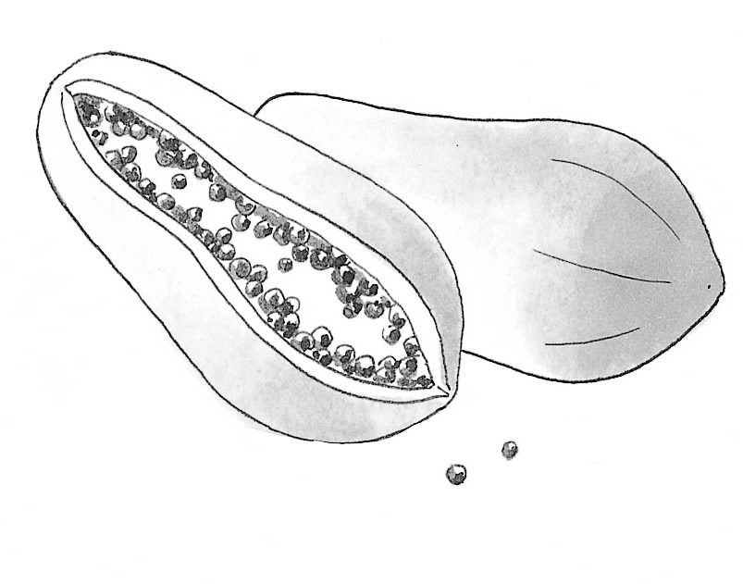 | 2. | 3.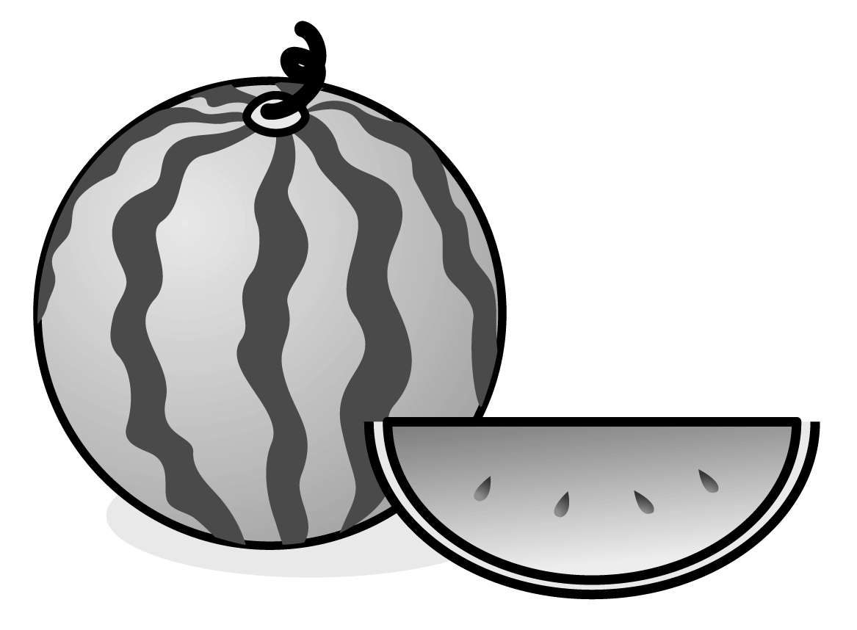 | 4.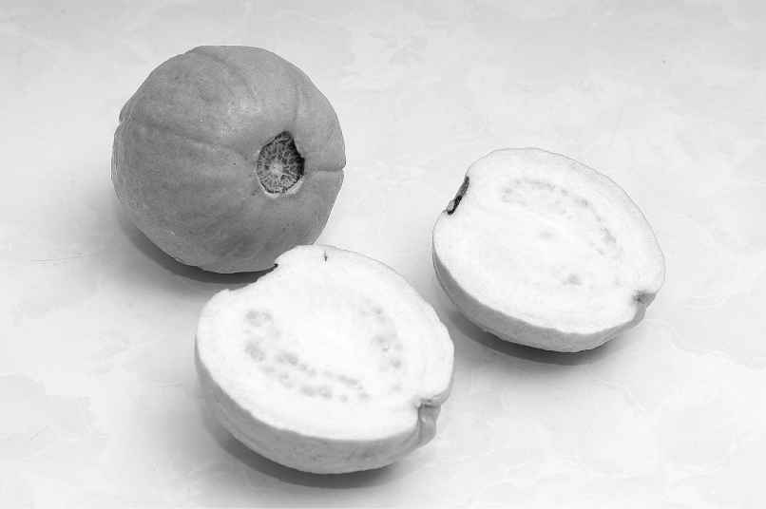
papaya | peach | watermelon | guava

5.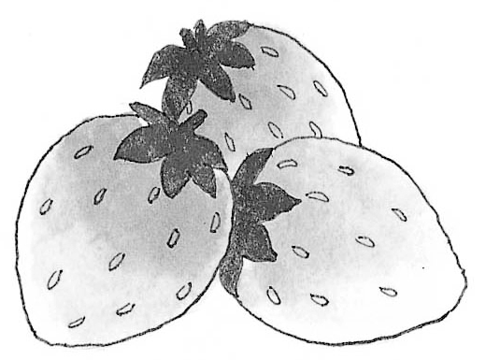 | 6.  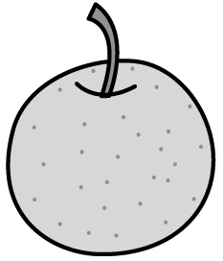 | 7.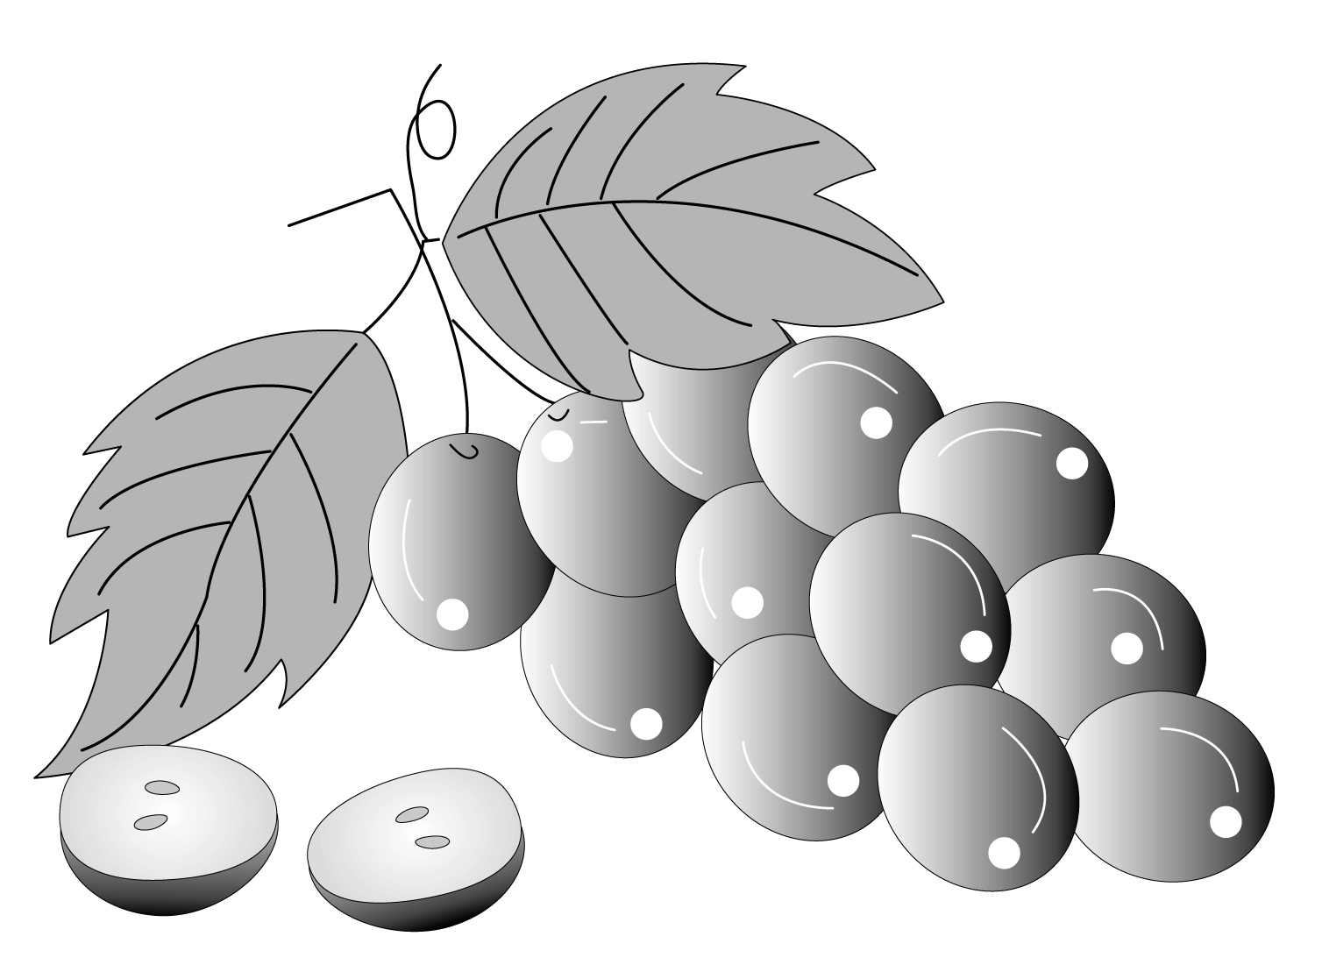
strawberry | pear | grape

三、選擇（每題5分，共25%）
1.（ C ） Mike’s English is better than .
(A) Tom (B) I (C) hers (D) us
2.（ B ） The chicken salad is special dish in this restaurant.
(A) the more (B) the most (C) most (D) more
3.（ A ） Lucky is of the two dogs.
(A) the smarter (B) the smartest (C) smarter (D) smartest
4.（ D ） Of the three balls, the red one is the most .
(A) big (B) pretty (C) heavy (D) expensive
5.（ B ） Becky is the saddest of .
(A) all of the girls (B) all the girls (C) the all girls (D) all of girls
基隆市98學年度第2學期南榮國中攜手計畫課業輔導學習單-4
科目：英語 學習內容：8下 Unit 2-2 班級：_______ 學生姓名：_______________
一、翻譯（每題14分，共70%）
1. A：這支手機是誰的？ B：是我的。
A: Whose cell phone is this? B: It’s mine.
2. 這間超市是附近最大的。
This supermarket is the biggest (one) around here.
3. 所有的梨子當中，他賣的最甜，最大。
He sells the sweetest and the biggest pears of all.
4. 看到這座美麗島嶼的最好且最方便的方法是什麼？
What is the best and most convenient way to see this island?
5. 臺北101是世界上最高的建築物。
Taipei 101 is the tallest building in the world.

二、閱讀（每題10分，共30%）
My closest friends are Mia, Ruby, Sussie, and Becky. Mia is as tall as Becky. But she is older. Sussie is shorter than Mia or Becky, but taller than Ruby. Of the four girls, Becky is the youngest. Ruby is older than Mia but younger than Sussie.

1.（ D ） Who is the shortest of the four girls?
(A) Sussie. (B) Becky. (C) Mia. (D) Ruby.
2.（ A ） Of the four girls, who is the second youngest?
(A) Mia. (B) Ruby. (C) Sussie. (D) Becky.
3.（ C ） Which is TRUE?
(A) Sussie is taller than Mia.
(B) Mia is younger than Becky.
(C) Becky is taller than Sussie.
(D) Mia is as old as Becky.

基隆市98學年度第2學期南榮國中攜手計畫課業輔導學習單-5
科目：英語 學習內容：8下 Unit 3-1 班級：_______ 學生姓名：_______________
一、文意字彙（每題5分，共60%）
1. basket Put your dirty clothes in the clothes b t. I’m going to wash
them in a minute.
2. drop The apples are beginning to d p from the tree.
3. hide Kids like to h e themselves under the desk, thinking that no one
will see them.
4. famous The coffee shop near our house is f s for its ice cream.
5. church They go to c h to worship(崇拜) on Sundays.
6. spoons We usually drink soup with s ns.
7. activity Mountain climbing is an outdoor(戶外的) a y.
8. rolled An egg r led off the table.
9. playground Most children enjoy shouting and running in the p d.
10. careful Emma is very c l with money. She seldom spends it.
11. adults Talking to a ts is sometimes difficult for children.
12. hunt Cats like to h t mice(老鼠).

二、依照圖，填入正確的字（每題5分，共15%）

1.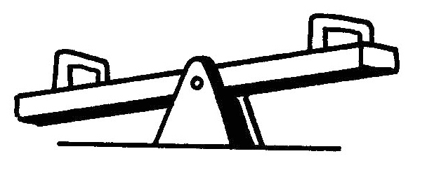 | 2.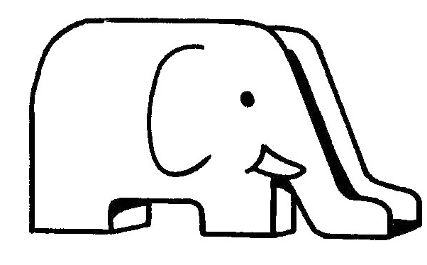 | 3.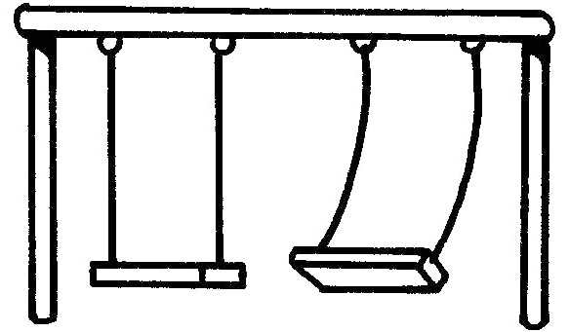
seesaw | slide | swing

三、選擇（每題5分，共25%）
1.（ D ） She talked to him .
(A) very quiet (B) more quiet (C) quieter (D) so quietly
2.（ B ） The kids are looking for their parents.
(A) nervous (B) sadly (C) quiet (D) good
3.（ B ） You worry about them.
(A) has not to (B) don’t have to (C) has to not (D) not have to
4.（ A ） The students .
(A) are listening carefully to their teacher (B) carefully are listening to their teacher
(C) are listening to carefully their teacher (D) are careful listening to their teacher
5.（ C ） The boy fell on the floor.
(A) heavy; heavy (B) heavily; heavily (C) heavy; heavily (D) heavily; heavy

基隆市98學年度第2學期南榮國中攜手計畫課業輔導學習單-6
科目：英語 學習內容：8下 Unit 3-2 班級：_______ 學生姓名：_______________
一、翻譯（每題14分，共70%）
1. 孩子們正緊張地把蛋藏在溜滑梯底下。
The kids are hiding the eggs under the slide nervously.
2. 小心，別掉落了那籃雞蛋。
Be careful. Don’t drop the basket of eggs.
3. 孫子們必須很快地且很小心把蛋滾到終點線。
The kids have to roll the eggs quickly and carefully to the finish line.
4. 遊樂場裡有許多小孩正快樂在盪鞦韆。
There are many kids playing happily on the swings in the playground.
5. 她必須走得很慢，因為她的腿很痛。
She has to walk slowly because her leg hurts very much.

二、閱讀（每題10分，共30%）
Linda and Irene are tall and thin. Linda runs fast. She always wins a race. Irene has beautiful long legs. She loves to dance, and she dances beautifully. She also plays basketball well. Mike and Allen are players. They play baseball. They have strong powerful muscles. They usually hit the ball hard. Annie is a smart girl. She studies hard and reads well. Sussie speaks politely. She never fails to say “please” and “thank you.” They are all students from Room 909. Their teacher, Mrs. Wu, is very proud of them.
powerful有力的 muscle肌肉 politely有禮貌地
fail忽略；忘記 proud感到光榮的

1.（ C ） Which is Linda?
schedule時間表 battery電池
schedule時間表 battery電池
schedule時間表 battery電池
(A)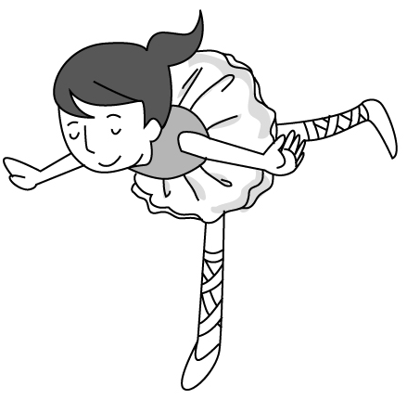 (B) 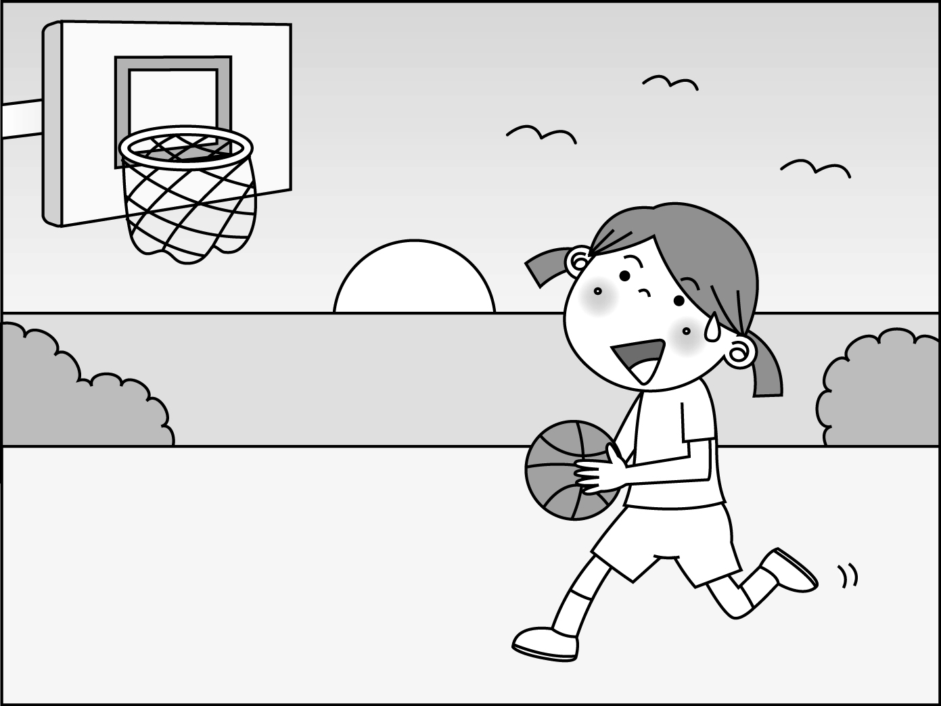 (C) 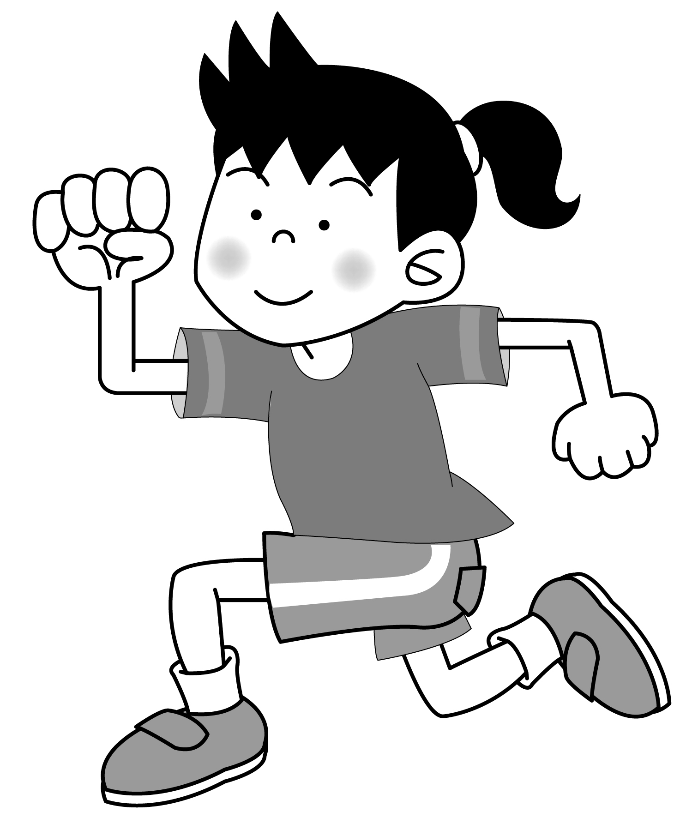 (D) 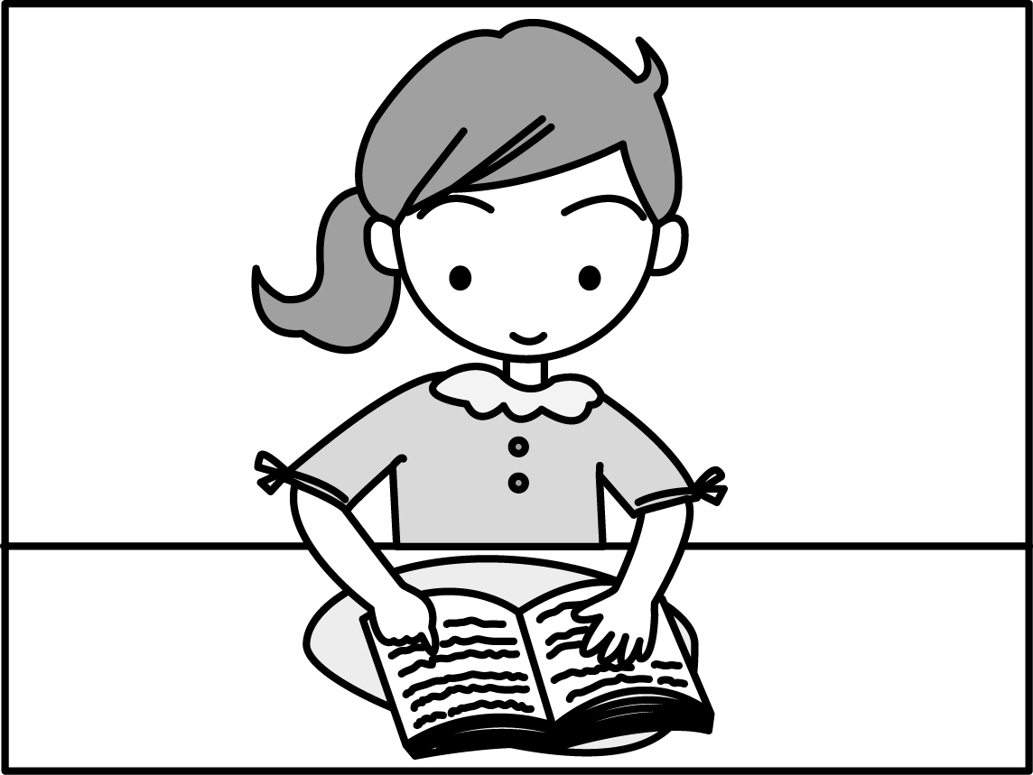
2.（ C ） Who is a basketball player?
(A) Linda. (B) Sussie. (C) Allen. (D) Annie.
3.（ B ） What does Sussie always remember to do?
(A) To study hard. (B) To say “please” and “thank you.”
(C) To hit the ball hard. (D) To win a race.

基隆市98學年度第2學期南榮國中攜手計畫課業輔導學習單-7
科目：英語 學習內容：8下 Unit 4-1 班級：_______ 學生姓名：_______________
一、文意字彙（每題5分，共60%）
1. thirsty I’m t y. Please get me some water.
2. factory My dad is a worker. He works in a shoe f y.
3. polluting Don’t throw your trash into the water. You are p ting it.
4. smoke It’s hot and full of s e in here. Let’s get out quickly.
5. loud You are too l d. I can’t hear the teacher.
6. angry Don’t make so much noise. The teacher is beginning to get
a y.
7. lonely The old man feels l y. He needs friends.
8. reduce To r e trash, people recycle bottles.
9. rested He was tired and r ted under a tree.
10. chance Bring an umbrella with you. There is a c e of rain later today.
11. smell Tommy, go wash your feet. They s l bad.
12. person Sam is a very good man. He is the right p n for this job.

二、選擇（每題5分，共40%）
1.（ D ） Tina sounded on the phone.
(A) quietly (B) badly (C) bright (D) unhappy
2.（ D ） Becky and Alex looked at each other.
(A) fine (B) finely (C) quiet (D) quietly
3.（ A ） A: does the cake taste ? B: It’s too sweet.
(A) How; X (B) What; X (C) What; how (D) How; what
4.（ B ） It sounds like .
(A) funny (B) fun (C) interesting (D) interestingly
5.（ C ） Don’t eat too much fast food. You will get .
(A) fat easy (B) easily fatty (C) fat easily (D) easy fat
6.（ B ） It looks like .
(A) to rain (B) rain (C) rains (D) rainy
7.（ A ） Mike is becoming more and more .
(A) handsome (B) heavily (C) coldly (D) nervously
8.（ C ） The roses good.
(A) are smells (B) are smelling like (C) smell (D) smell like

基隆市98學年度第2學期南榮國中攜手計畫課業輔導學習單-8
科目：英語 學習內容：8下 Unit 4-2 班級：_______ 學生姓名：_______________
一、依提示作答（每題14分，共28%）
1. The story sounds interesting.（依畫線部分造原問句）
How does the story sound?
2. The tea tastes like water.（依畫線部分造原問句）
What does the tea taste like?
二、翻譯（每題14分，共42%）
1. 我覺得很餓，但是沒有任何多的食物了。
I feel hungry, but there isn’t any more food.
2. 看啊！那間工廠正排放出大量的煙。
Look! There is a lot of smoke coming out of the factory.
3. 他們變得累了，所以在溪邊的草地上休息。
They became tired, so they rested on the grass by the stream.

三、閱讀（每題10分，共30%）
For each kind of fruit, Han-lin Supermarket provides 800 grams for customers to shop for. Study the chart carefully and answer the following questions.

 |  | Mon. | Wed. | Fri. | Sun
 | NT$ / 100g | NT$80 | NT$75 | NT$80 | NT$70
 | sold out | 300g | 200g | 350g | 120g
 | turned bad | 50g | 0g | 20g | 40g
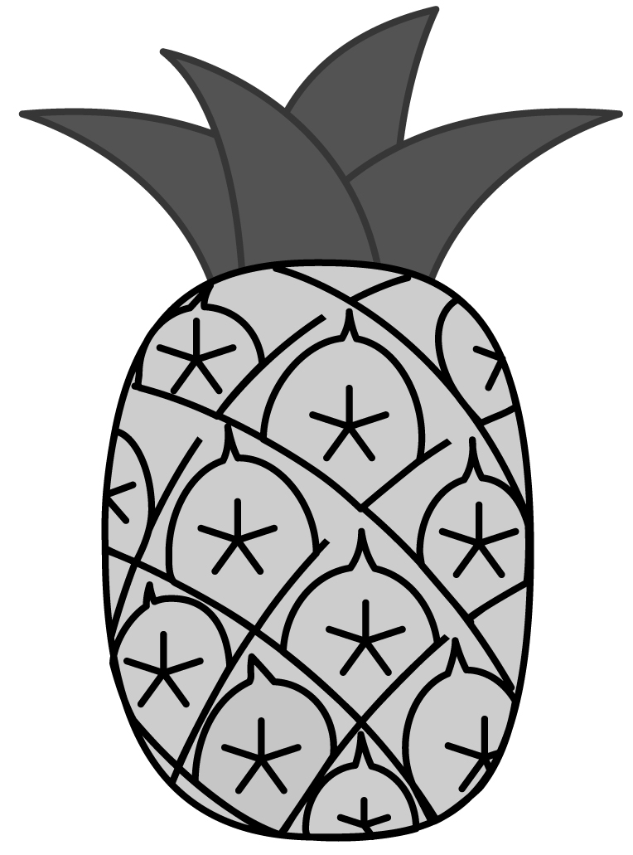 | NT$ / 100g | NT$90 | NT$90 | NT$85 | NT$100
 | sold out | 300g | 450g | 600g | 800g
 | turned bad | 10g | 0g | 20g | 0g
 | NT$ / 100g | NT$50 | NT$200 | NT$400 | NT$600
 | sold out | 200g | 200g | 200g | 200g
 | turned bad | 100g | 200g | 300g | 350g
 | NT$ / 100g | NT$110 | NT$200 | NT$110 | NT$110
 | sold out | 700g | 500g | 400g | 450g
1.（ A ） Which fruit is becoming more and more expensive?
(A) Strawberries. (B) Pineapples. (C) Peaches. (D) Watermelons.
2.（ C ） Which fruit is becoming more and more popular?
(A) Watermelons. (B) Strawberries. (C) Pineapples. (D) Peaches.
3.（ D ） Which fruit turns bad most easily?
(A) Peaches. (B) Pineapples. (C) Watermelons. (D) Strawberries.
基隆市98學年度第2學期南榮國中攜手計畫課業輔導學習單-9
科目：英語 學習內容：8下 Unit 5-1 班級：_______ 學生姓名：_______________
一、文意字彙（每題5分，共35%）
1. lamp She turned on the desk l p to read.
2. mouse I caught a m e eating up the cake on the plate.
3. candles They lighted the c es because the lights suddenly went out.
4. laughed The story sounded funny and everyone l hed out loud.
5. moment Just at that m t, the telephone rang.
6. hands To keep your h ds clean, always remember to wash them before
and after your meals.
7. giant A big, strong man is like a g t to little kids.

二、依照圖，填入正確的字（每格5分，共35%）

1. (a) | (b) 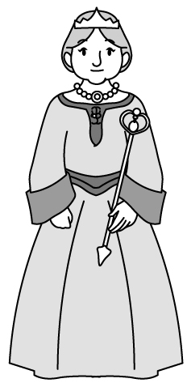 | 2. (a) 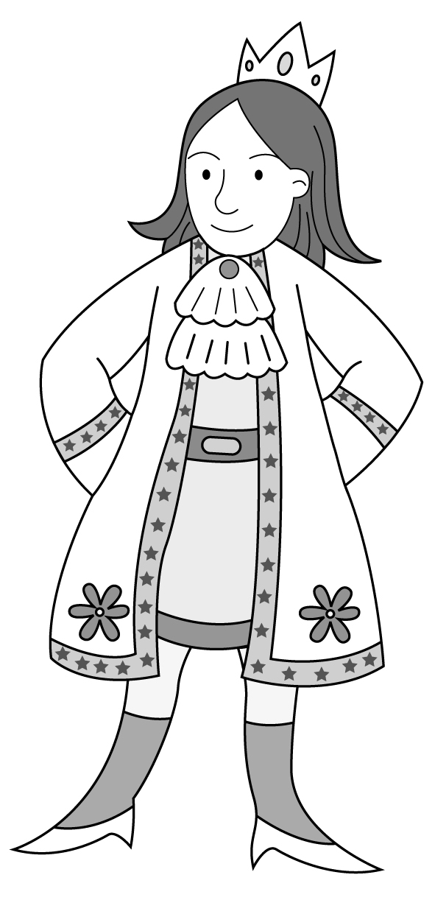 | (b) 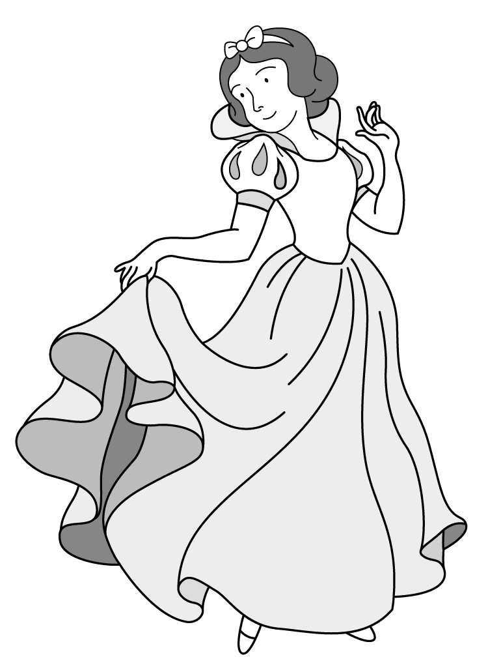
king | queen | prince | princess

3. 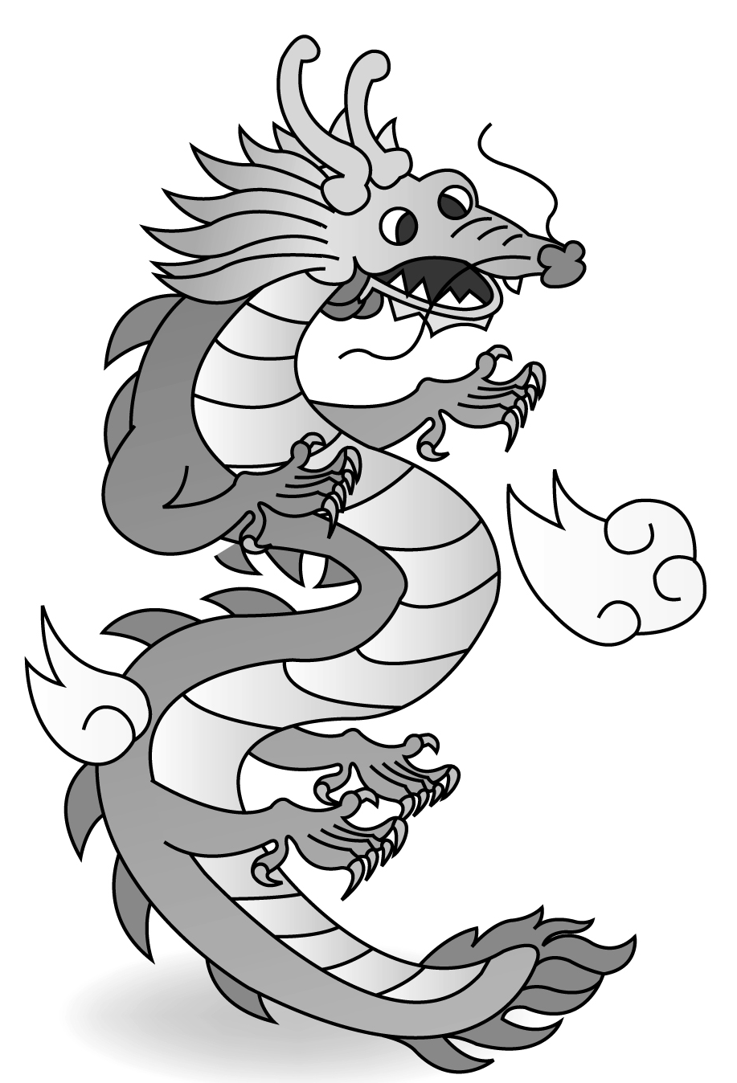 | 4. (a) 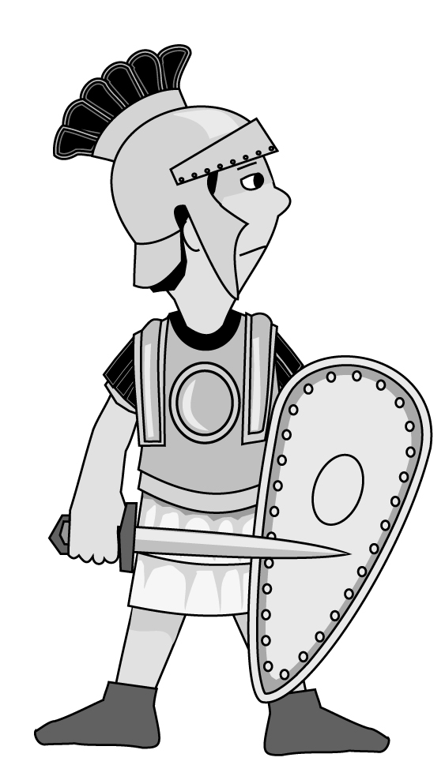 | (b) 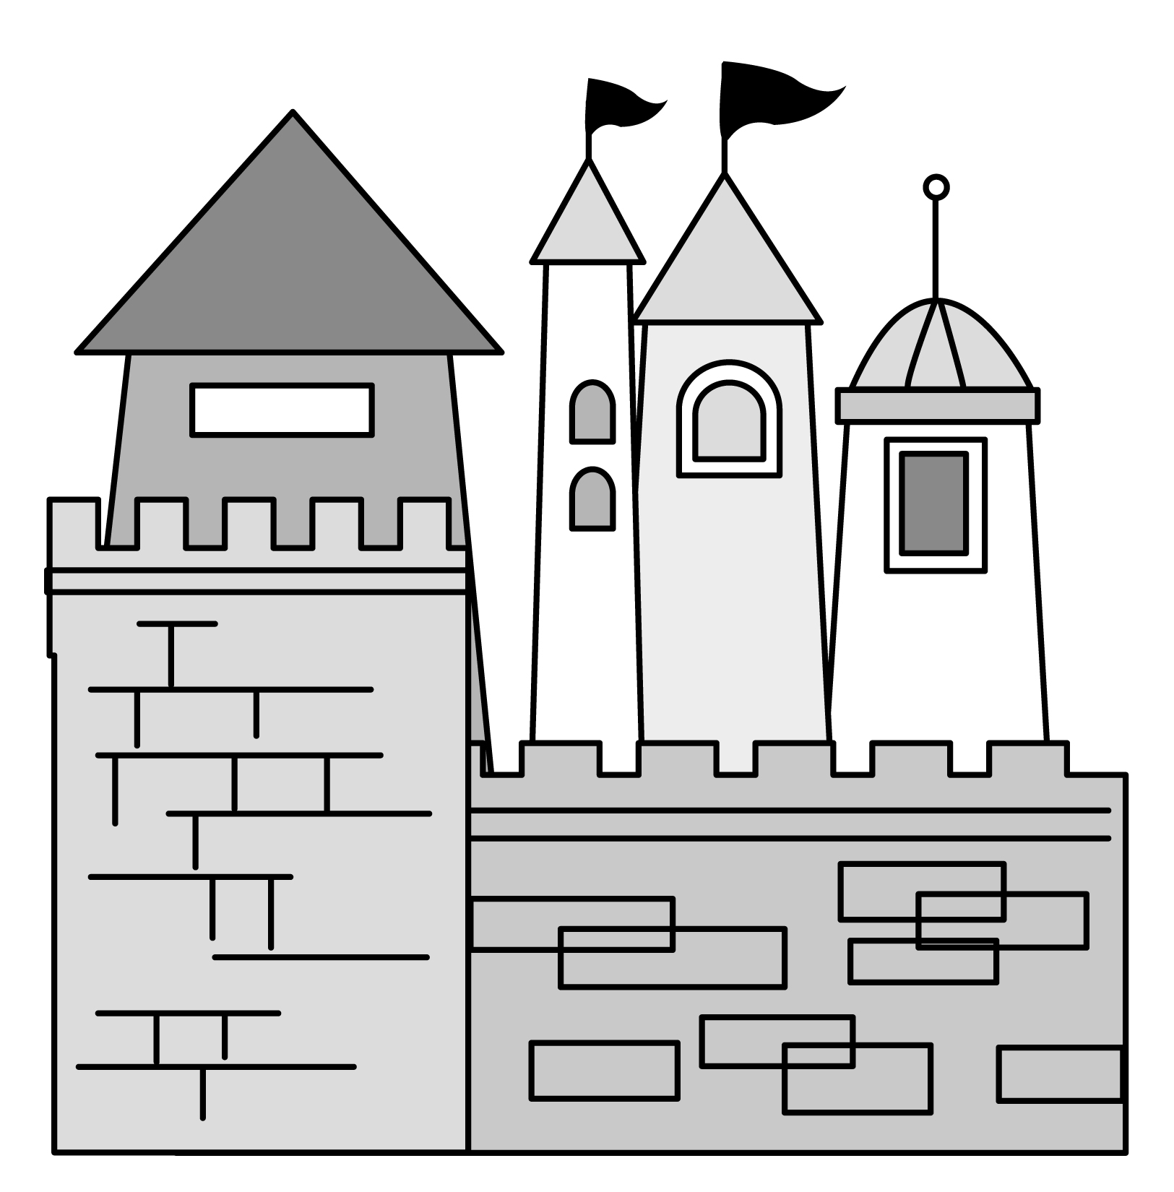
dragon | soldier | castle

三、選擇（每題5分，共30%）
1.（ C ） She her umbrella and went out of the room.
(A) put on (B) turned on (C) picked up (D) give up
2.（ B ） Mom won’t let me my breakfast with coffee.
(A) to have (B) have (C) having (D) had
3.（ B ） Have Ted the room himself. Don’t do it for him.
(A) to clean up (B) clean up (C) cleaning up (D) cleans up
4.（ A ） What makes you so?
(A) say (B) said (C) says (D) saying
5.（ A ） The Chens went on a trip, so their neighbor helped their dog.
(A) to take care of (B) took care of (C) takes care of (D) taking care of
6.（ D ） I bought new socks for you.
(A) Try on this. (B) Try it on. (C) Try this on. (D) Try them on.

基隆市98學年度第2學期南榮國中攜手計畫課業輔導學習單-10
科目：英語 學習內容：8下 Unit 5-2 班級：_______ 學生姓名：_______________
一、依提示作答（每題14分，共28%）
1. Tina picked up her clothes and got on her bike.（畫線部分改為代名詞，並做必要變化）
Tina picked them up and got on it.
2. The king wanted the soldiers to stand in front of the castle.
（畫線部分以make改寫，並做必要變化）
The king made the soldiers stand in front of the castle.
二、翻譯（每題14分，共52%）
1. 那個巫婆迫使公主清洗缸子而沒有讓她休息。
The witch made the princess wash the tub and didn’t let her rest.
2. 他下了公車並戴上帽子。
He got off the bus and put on his hat.
3. 因為他們的幫助，她沒有事情要擔心了。（With… nothing…）
With the help of them, she had nothing to worry about.
三、閱讀（每題10分，共30%）
Ben : Peter, will you throw away the rotten apple on the desk in your bedroom?
Peter : Just a minute, Dad. I’m online.
Amy : Hurry up, Peter! Go clean up your room at once.
Peter : In a minute, Mom.
Susan : Peter, I see many toys under your bed. Why don’t you give some away?
Peter : I will, Grandma. Don’t worry.
Irene : Peter, did you see my toe socks? Oh, those pants on your bed smell bad. I must get out of this room. I can’t stand the smell any longer.
Peter : Well, I can’t, either. I want to get out of here, too.
schedule時間表 battery電池
schedule時間表 battery電池
1.（ D ） Who made Peter clean his room?
(A) Susan. (B) Ben. (C) Irene. (D) Amy.
2.（ C ） Why did Susan have Peter give away the toys?
(A) The toys were too old. (B) The toys were too dirty.
(C) He had too many toys. (D) The toys had a bad smell.
3.（ D ） Why did Peter want to get out of the room himself?
(A) The room was too dirty. (B) There was a rotten apple.
(C) There were toys under his bed. (D) His pants smelled bad.
rotten腐壞的 online連線 at once立刻 must必須 stand忍受

基隆市98學年度第2學期南榮國中攜手計畫課業輔導學習單-11
科目：英語 學習內容：8下 Unit 6-1 班級：_______ 學生姓名：_______________
一、文意字彙（每題5分，共50%）
1. firefighter A f r puts out fires for us.
2. body To have a strong b y, you have to exercise more.
3. health Drinking and smoking are bad for your h h.
4. brave It was b e of him to sing in front of so many people.
5. choose For juice, you can c e between orange and grape.
6. future A: What do you want to be in the f e? B: A writer.
7. question This is a very difficult q n. I don’t know the answer.
8. interest At the age of three, he showed great i t in dancing.
9. interview A reporter’s job is to i w people.
10. snake Be careful! There’s a s e sliding down the tree.

二、請依照圖，填入正確的字（每題5分，共20%）

1. 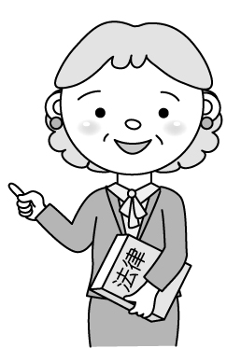 | 2.  | 3. 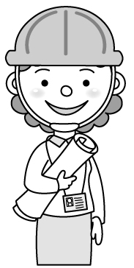 | 4. 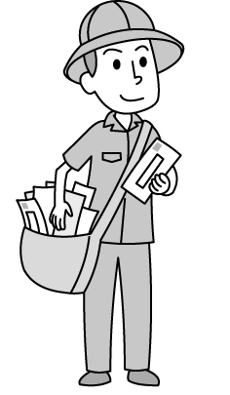
lawyer | secretary | engineer | mail carrier

三、選擇（每題6分，共30%）
1.（ D ） of her parents are nice to us.
(A) All (B) Two (C) Any (D) Both
2.（ C ） To be strong, you eat right and exercise often.
(A) shouldn’t (B) need (C) must (D) won’t
3.（ A ） of them has to sweep the stairs.
(A) One (B) All (C) Some (D) Most
4.（ A ） Most of the girls’ hair white.
(A) is (B) look (C) become (D) turn
5.（ C ） One of my hands is dry; is wet.
(A) none (B) other (C) the other (D) others

基隆市98學年度第2學期南榮國中攜手計畫課業輔導學習單-12
科目：英語 學習內容：8下 Unit 6-2 班級：_______ 學生姓名：_______________
一、依提示作答（每題14分，共28%）
1. One student was late today.（將one改為不定數量代名詞）
One of the students was late today.
2. You have to be a careful worker.（將動詞改為助動詞，形容詞改為副詞，句意不變）
You must work carefully.
二、翻譯（每題14分，共42%）
1. 警察必須勇敢且健康狀況佳。
A policeman must be brave and be in good health.
2. 其中大多數的男演員和女演員未來想要成名。
Most of the actors and actresses want to become famous in the future.
3. 冰箱裡所有的食物都很新鮮可口。
All of the food in the refrigerator is fresh and delicious.
三、閱讀（每題10分，共30%）
Look at the chart. What do the students in Class 816 want to be?
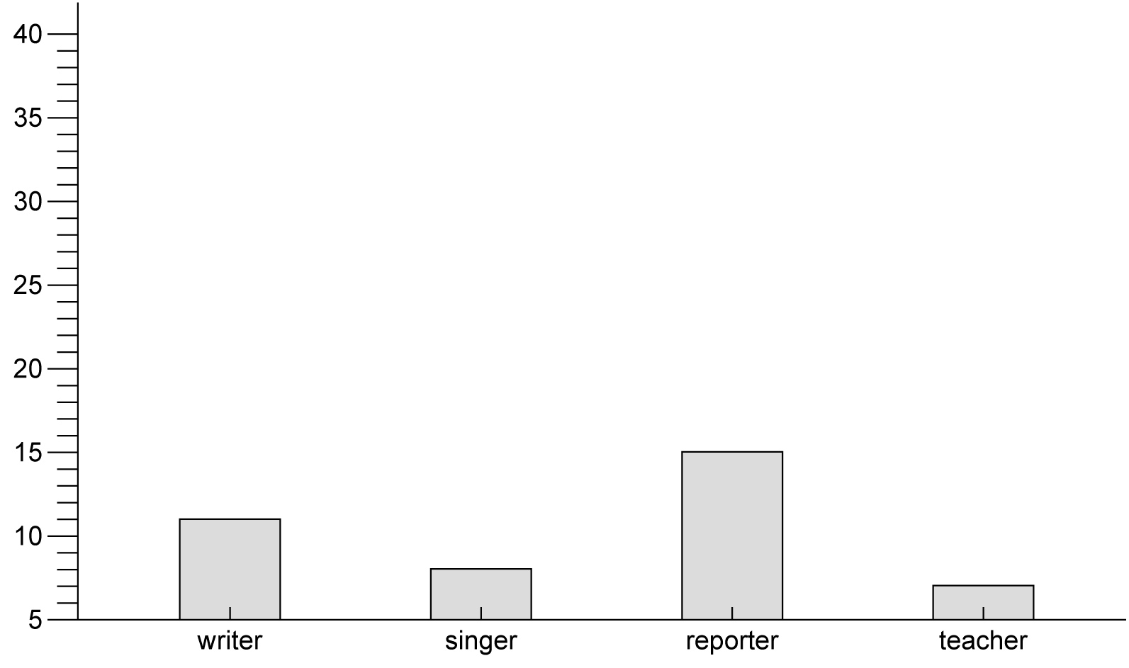
1.（ B ） How many students are there in class 816?
pair 一雙 over 超過
cash 現金 coupon優惠卷
tell知道
(A) Forty. (B) More than forty. (C) Less than forty. (D) We can’t tell.
2.（ A ） How many of the students want to be a writer?
(A) Eleven. (B) Fifteen. (C) Seven. (D) Eight.
3.（ D ） What do most of the students want to be?
(A) A singer. (B) A teacher. (C) A writer. (D) A reporter.

基隆市98學年度第1學期南榮國中攜手計畫課業輔導學習單-13
科目：英語 學習內容：8下 Unit 7-1 班級：_______ 學生姓名：_______________
一、文意字彙（每題5分，共50%）
1. safe It isn’t s e for kids to stay at home by themselves.
2. lazy He felt very l y and didn’t want to get out of bed.
3. clear It’s a sunny day today. The skies are c r and blue.
4. program Turn on the TV, please. My favorite p will be on in a minute.
5. clouds The c ds are becoming dark and heavy. It’s going to rain.
6. miles They live m es away on the other side of town.
7. bench Linda and Sussie sat on the park b h and had their meal.
8. blow The coffee is too hot, so I will b w on it to cool it down.
9. lovely You look l y in that skirt.
10. wind We couldn’t put up the tent(帳篷) because the w d was too strong.

二、依照圖，填入正確的字（每題5分，共25%）

1. | 2. | 3. | 4.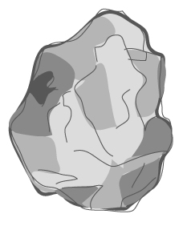 | 5.
sun | star | wave | rock | rainbow

三、選擇（每題5分，共25%）
1.（ A ） The parents are watching their kids and in the playground.
(A) running; playing (B) are running; are playing
(C) to run; to play (D) to run; play
2.（ C ） I couldn’t hear them . Let’s get closer to them.
(A) talked (B) talks (C) talk (D) to talk
3.（ D ） We walked along the beach to see the sun down.
(A) went (B) goes (C) was going (D) go
4.（ B ） Planes can fly than birds.
(A) more highly (B) higher (C) more fast (D) more fastly
5.（ C ） He finished reading the book more than I.
(A) early (B) lately (C) quickly (D) slower

基隆市98學年度第2學期南榮國中攜手計畫課業輔導學習單-14
科目：英語 學習內容：8下 Unit 7-2 班級：_______ 學生姓名：_______________
一、依提示作答（每題14分，共28%）
1. The bird sings every morning. I enjoy listening to it.（合併為一句）
I enjoy listening to the bird sing every morning.
2. Patty did badly in English. She did very badly in Chinese.（以比較級副詞合併句子）
Patty did worse in Chinese than in English.

二、翻譯（每題14分，共42%）
1. 沿途，他們可以感覺到風吹得很強。
They could feel the wind blowing very strongly along the way.
2. 我們將可以及時回來看我最喜愛的電視節目嗎？
Will we be able to get back in time to watch my favorite TV program?
3. A：你騎了多遠？ B：幾英里。
A: How far did you ride? B: A few miles.

三、閱讀（每題10分，共30%）
At 11:45 p.m. on September 8th, there was an accident between a motorcycle and a car on the corner of Station Road and Park Street. It was raining at the time of the accident and the street light on the corner of Station Road and Park Street was not working, making it even more difficult to see. Also, there was a large truck parking on Park Street, near the corner. The motorcyclist turned onto the corner into Park Street and didn’t see the car coming. The driver of the car was a young woman. She was not hurt, but the motorcyclist broke his arm. And he had to go to the hospital.
accident意外 even更加 park停車 motorcyclist摩托車騎士
1.（ D ） When did the accident happen?
(A) In the morning. (B) In the afternoon. (C) At noon. (D) At night.
2.（ C ） Why didn’t the motorcyclist see the car coming?
(A) The street light was not bright enough.
(B) The motorcyclist was going too fast.
(C) There was a truck near the street corner.
(D) The streets were too wet.
3.（ B ） Which is not true?
(A) The accident happened on a rainy day.
(B) The motorcyclist was a young woman.
(C) The driver of the car was fine.
(D) It was dark at the street corner.

基隆市98學年度第2學期南榮國中攜手計畫課業輔導學習單-15
科目：英語 學習內容：8下 Unit 8-1 班級：_______ 學生姓名：_______________
一、文意字彙（每題5分，共65%）
1. failed The doctor did everything to save the girl’s life, but he f led.
2. prepare We have to p e some boats for the boat race next month.
3. cheating Don’t copy from me - that’s c ting.
4. correct Your writing is full of spelling mistakes. Please c t them.
5. quiz I seldom watch talk shows or q z shows.
6. collect I c t teddy bears, and I have many of them on my bed.
7. seat Have a s t and make yourself at home.
8. review You have to r w your lessons before the test.
9. pass She has to p s the bookstore on her way to school.
10. habit Many people have the h t of getting up late on weekends.
11. grade Amy worked hard and had a g e A in English.
12. decide A: Did you d e on a date for the barbecue?
B: Yes, On the 21st of this month.
13. groups Class, get into g ps and start your work.

二、選擇（每題5分，共35%）
1.（ A ） We will get there before it dark tonight.
(A) gets (B) will get (C) is getting (D) gotten
2.（ C ） the phone rang, I was taking a bath.
(A) If (B) During (C) When (D) Because
3.（ B ） After she read to her baby, she the lights off.
(A) turns (B) turned (C) will turn (D) is turning
4.（ D ） Sussie washed the vegetables she cooked them.
(A) or (B) good (C) but (D) before
5.（ A ） After she the toys, she went to bed.
(A) put away (B) was putting away
(C) will put away (D) would put away
6.（ D ） Ted runs in his class.
(A) the faster (B) fast (C) faster (D) the fastest
7.（ D ） When Dad the door, Lucky up and down to welcome him.
(A) will open; will jump (B) will open; jumps
(C) will be opening; was jumping (D) opened; jumped

基隆市98學年度第2學期南榮國中攜手計畫課業輔導學習單-16
科目：英語 學習內容：8下 Unit 8-2 班級：_______ 學生姓名：_______________
一、依提示作答（每題14分，共28%）
1. The waiter dropped the plate on the floor. It broke into pieces.（以...when...合併）
The plate broke into pieces when the waiter dropped it on the floor.
2. We will take a ten-minute break. Then we’ll come back to our lessons.
（以After...合併句子）
After we take a ten-minute break, we’ll come back to our lessons.
二、翻譯（每題14分，共42%）
1. 當她決定了考試要作弊時，她的心開始跳得很快。（When...）
When she decided to cheat on the test, her heart began to beat fast.
2. 那位先生就座之後對我說謝謝。（...after...）
The old man said thank you to me after he took his seat.
3. 老師收考卷前，你必須寫下名字。（...before...）
You have to write down your name before the teacher collects the test / exam papers.
三、閱讀（每題10分，共30%）
The Joy Washing Machine
Instructions
1. Press the button to open the door of the washing machine.
2. Put the dirty clothes into the washing machine and add half a cup of washing powder.
3. Close the door and choose the water temperature.
4. Turn on the machine.
5. The machine will wash the clothes and rinse them.
6. When the machine finishes washing the clothes, you will hear a bell ring.
7. The machine will stop running.
8. Leave the clothes in the washing machine and press the button for drying.
9. Choose how long you want the clothes to be in the washing machine and then press the On button.
10. When the clothes are dry, you will hear the bell again.

Instruction指示 press按 button按鈕 add加入
washing powder洗衣粉 temperature溫度 rinse沖洗

1.（ C ） What do you do after you put the clothes into the washing machine?
(A) Press the On button. (B) Choose the water temperature.
(C) Add the washing powder. (D) Press the button for drying.
2.（ B ） When will we hear the bell ring?
(A) When you press the button to open the door.
(B) When the clothes are dry.
(C) When you press the On button.
(D) When the machine starts rinsing the clothes.
3.（ A ） When do we press the On button?
(A) After choosing how long we want the clothes to be in the machine.
(B) Before choosing the water temperature.
(C) When opening the door of the machine.
(D) When the machine stops running.

基隆市98學年度第2學期南榮國中攜手計畫課業輔導學習單-17
科目：英語 學習內容：8下 Unit 9-1 班級：_______ 學生姓名：_______________
一、文意字彙（每題5分，共45%）
1. package I sent him the gift in one big p e.
2. glad I am g d to be back home.
3. dentist Her teeth fell out, so she went to the d t.
4. sharp Mom used a s p knife to cut away the fatty meat.
5. pain Mike can’t walk fast because he has a p n in his leg.
6. treat It is wrong to t t animals badly.
7. without We can’t live w t air or water.
8. excellent Becky is e t at keeping the house clean.
9. elementary Mrs. Chen teaches Chinese at an e y school.

二、依照圖，填入正確的字（每題5分，共30%）
1. 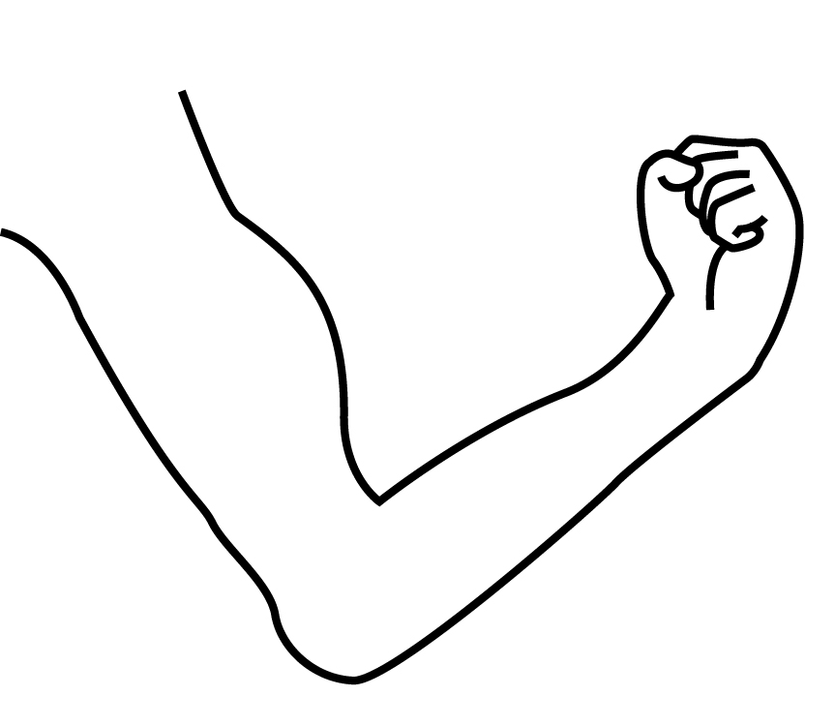 | 2. 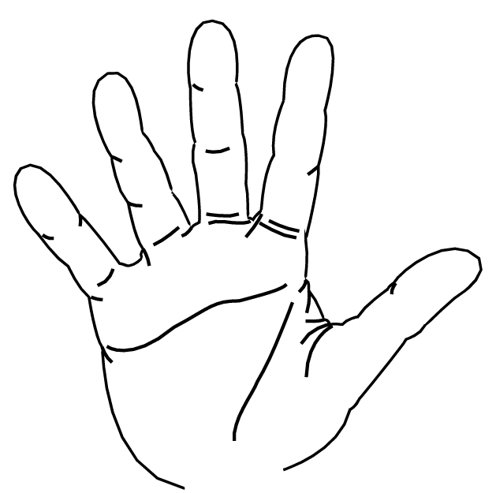 | 3. 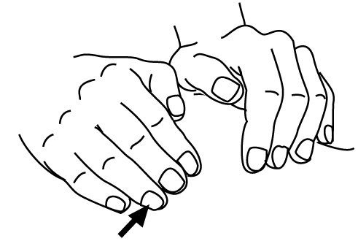
arm | finger | nail

4.  | 5. 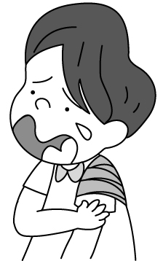 | 6. 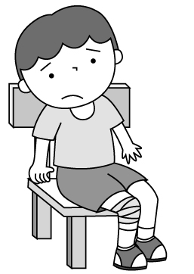
neck | shoulder | knee

三、選擇（每題5分，共25%）
1.（ C ） If it rain tomorrow, we’ll go camping.
(A) isn’t (B) didn’t (C) doesn’t (D) hasn’t
2.（ D ） He gets tired easily he looks strong.
(A) because (B) when (C) if (D) although
3.（ B ） Go to the doctor you don’t feel good.
(A) although (B) if (C) or (D) so
4.（ A ） The washing machine is old, it works well.
(A) but (B) if (C) and (D) when
5.（ C ） If you read the book twice, you it better.
(A) are understanding (B) were understanding
(C) will understand (D) do understand
基隆市98學年度第2學期南榮國中攜手計畫課業輔導學習單-18
科目：英語 學習內容：8下 Unit 9-2 班級：_______ 學生姓名：_______________
一、依提示作答（每題14分，共42%）
1. Mr. Chen didn’t find a job. His wife didn’t find a job.（合併為附和句）
Mr. Chen didn’t find a job, and his wife didn’t, either.
2. He will join us. We will make an excellent team.（以...if...合併句子）
We will make an excellent team if he joins us.
3. Rick put a cold pack on Sandy’s arm, but it still hurt.（以Although...合併句子）
Although Rick put a cold pack on Sandy’s arm, it still hurt.
二、翻譯（每題14分，共28%）
1. 如果你的脖子受傷了，你可能無法轉動你的頭部。
If you hurt your neck, you may / might not be able to turn your head.
2. 沒有吃藥，你將會感覺到胃部的強烈疼痛。
You will feel a sharp pain in your stomach without taking medicine.
二、閱讀（每題10分，共30%）

TOKYO | HONG KONG
Tokyo is the biggest city in Asia. You can find the world’s first fastest and cleanest train-the bullet train. You’ll find the oldest temple in Japan. | Take a boat trip around the world’s most beautiful harbour. Shop in the famous Nathan Road and try the best Chinese food in the world. Take the hydrofoil from Hong Kong to Macao.
BANGKOK | SINGAPORE
Bangkok is the city of temples. It has some of the most beautiful temples in Asia. Women can buy beautiful silk dresses here. | Singapore is Asia’s smallest country and cleanest city. It is a green city with beautiful gardens and parks. Take a boat trip around the island and see one of the busiest harbours in the world-Singapore Harbour.
Asian亞洲的 tour旅行 Tokyo東京 Asia亞洲 bullet train子彈列車
travel旅遊 Osaka大阪 temple寺廟 Japan日本 harbour碼頭
hydrofoil水翼船 Macao澳門 Bangkok曼谷 silk絲製的 Singapore新加坡

1.（ B ） If you visit Tokyo, what will you find?
(A) The oldest temple. (B) The bullet train.
(C) Silk dresses. (D) Beautiful gardens and parks.
2.（ A ） If you want to travel on the hydrofoil, where can you visit?
(A) Hong Kong. (B) Tokyo. (C) Singapore. (D) Osaka.
3.（ C ） Which city has the most temples?
(A) Osaka. (B) Macao. (C) Bangkok. (D) Singapore.

